

Gone sin Mal

Use Case Diagrams and Descriptions



Bit Geeks

Min Thu Khant

Contents

1. Overall Use case Diagram 2

2. Customer View Application Use case Diagram 3

3. Reataurant View Application Use case Diagram 5

4. Admin Side Application Use Case Diagram 10

5. QR Scan Use Case Diagram 12

# 1. Overall Use case Diagram

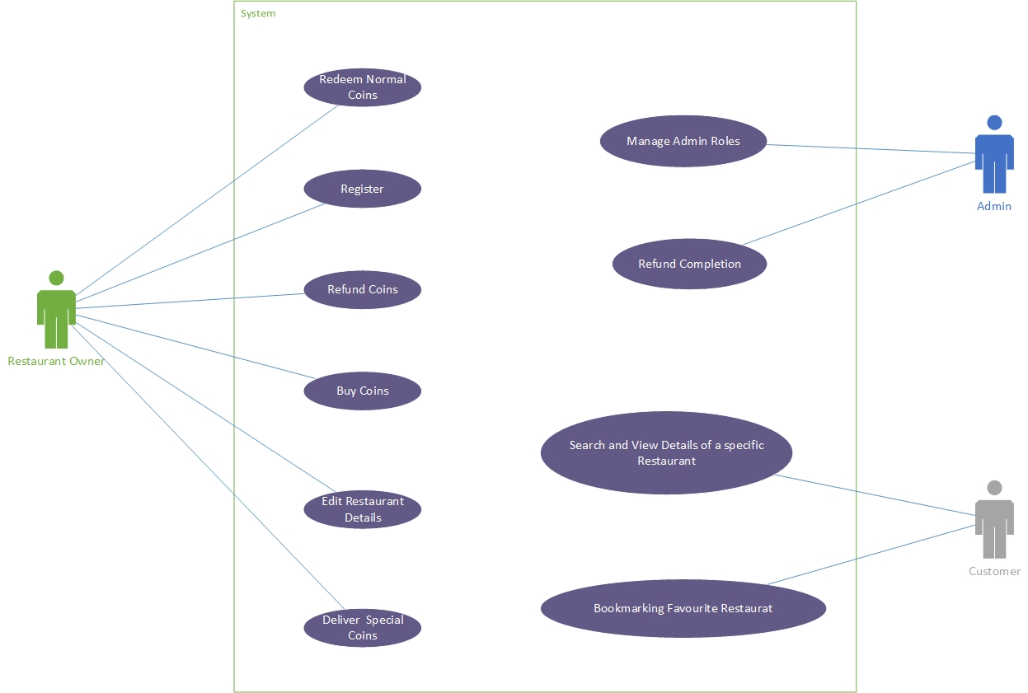

*Use Case Diagram for the whole system*

# 2. Customer View Application Use case Diagram

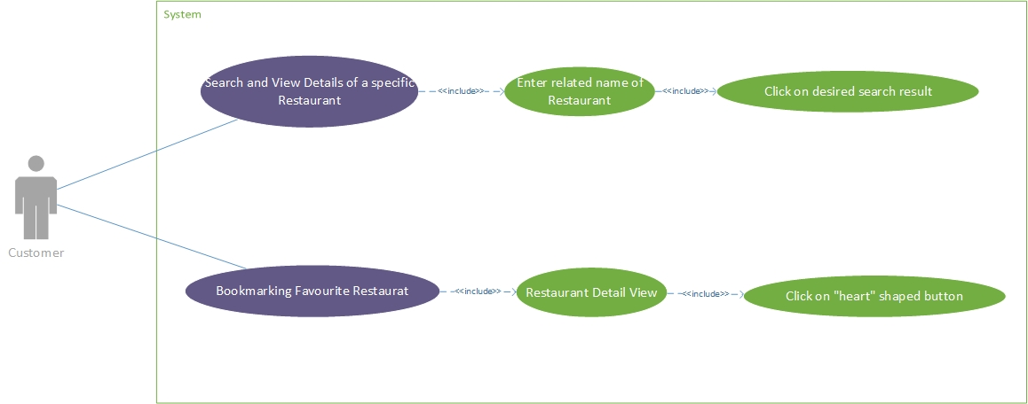

*Customer Side Application Use Case Diagram*

|  |  |  |
| --- | --- | --- |
| Use case Name: | Search and View Details of a specific Restaurant | |
| Actor Name: | Customer | |
| Related Use case: | 1. Enter related name of Restaurant, 2.)Click on desired search result | |
| Goal: | Open restaurant detail view | |
| Precondition: | Customer must login | |
| Summary: |  | |
| Step | **Actor** | **System** |
| 1 | Focus on Search bar | show search page and auto focus on search bar |
| 2 | Enter keyword |  |
| 3 | Press search button | Show search result |
| 4 | Click on desired search result | Show restaurant detail page |
| Post Condition: | Show restaurant detail page | |

|  |  |  |
| --- | --- | --- |
| Use case Name: | Bookmarking Favorite Restaurant | |
| Actor Name: | Customer | |
| Related Use case: | 1.) Restaurant Detail View, 2.) Click on "heart" shaped button | |
| Goal: | Restaurant will be added to favorite list | |
| Precondition: | Customer must login | |
| Summary: |  | |
| Step | **Actor** | **System** |
| 1 | Click on Detail view of desired restaurant | Show restaurant detail page |
| 2 | Click on "heart" shaped button | “heart” shape button turned red |
| 3 | Press on Favorite button navigation bar | Restaurant will be added to favorite list |
| Post Condition: | Restaurant will be added to favorite list | |

# 3. Reataurant View Application Use case Diagram

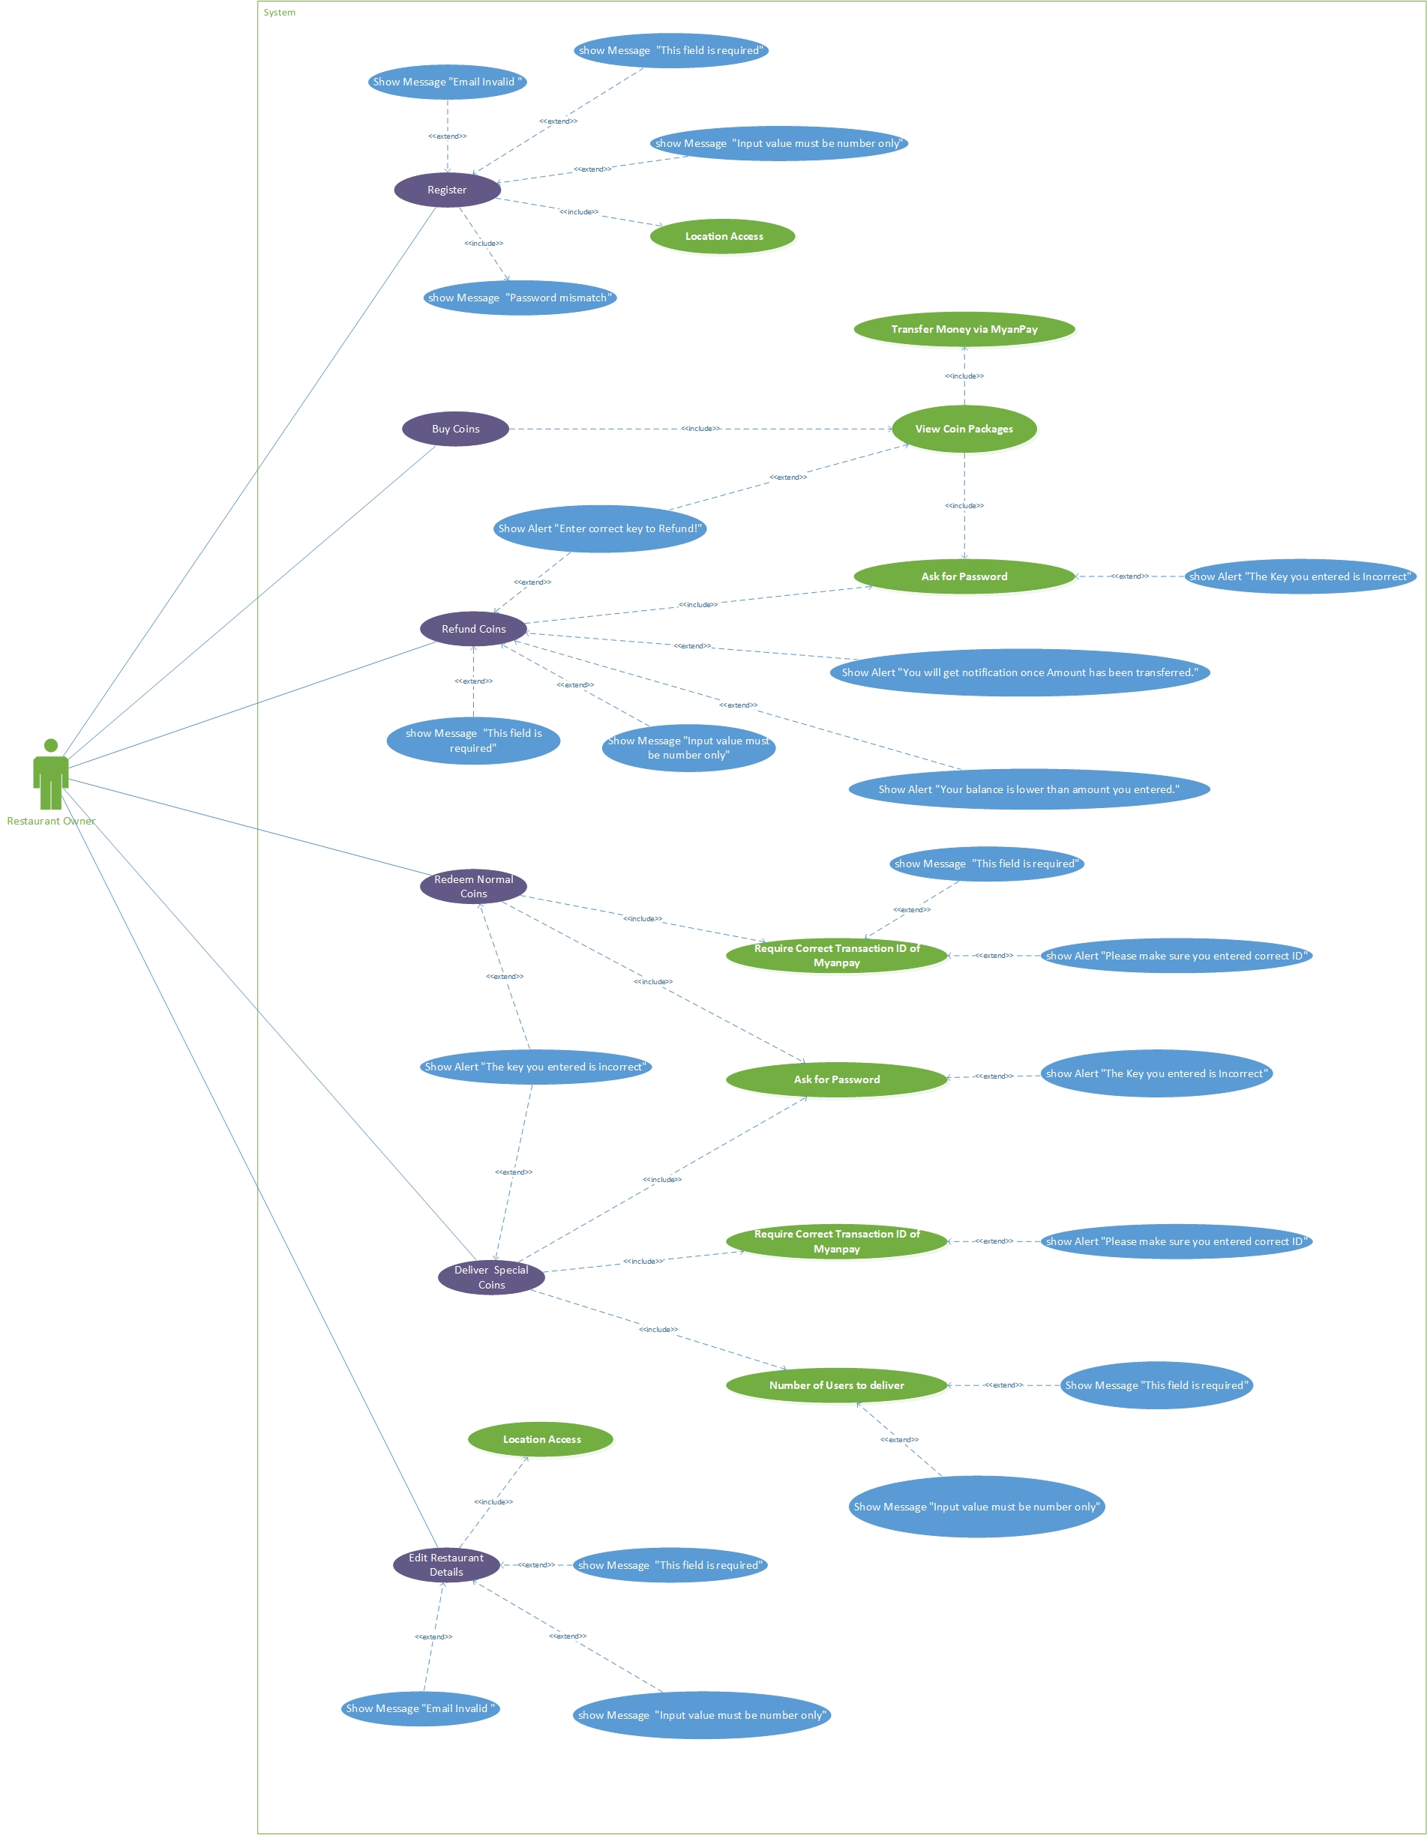

*Restaurant Side Application Use Case Diagram*

|  |  |  |
| --- | --- | --- |
| Use case Name: | Register | |
| Actor Name: | Restaurant | |
| Related Use case: | 1.) Show Message "Email Invalid ", 2.) show Message “This field is required", 3.) show Message “Input value must be number only", 4.) show Message “Password mismatch", 5.) Location Access | |
| Goal: | Restaurant will be Registered. | |
| Precondition: | User Must Login into Restaurant | |
| Summary: |  | |
| Step | **Actor** | **System** |
| 1 | Click “Next” Button | Show Message “This field is required" if all fields are not inserted.  Show Message "Email Invalid” if Email format is not correct.  Show Message “Input value must be number only” if phone number field is inserted by character value.  Show Message “Password mismatch" if two password fields are not same.  Show Home page of Restaurant view if all condition are correct. |
| Post Condition: | Show Home page of Restaurant view | |

|  |  |  |
| --- | --- | --- |
| Use case Name: | Buy Coins | |
| Actor Name: | Restaurant | |
| Related Use case: | 1.) View Coin Packages, 2.) Transfer Money via MyanPay, 3.) Ask for Password, 4.) show Alert "The Key you entered is Incorrect" | |
| Goal: | Will get Transaction Confirm message | |
| Precondition: | User Must Login into Restaurant | |
| Summary: |  | |
| Step | **Actor** | **System** |
| 1 | Click on Coins Page | Ask for password. Show Alert "The Key you entered is Incorrect". |
| 2 | Click on Normal or Special Coin | Show Alert "The Key you entered is Incorrect" if password is not correct.  Transfer Money via MyanPay if entered password is correct. |
|  |  | Send Notification to Restaurant |
| Post Condition: | Get Transaction Confirm message to notification page | |

|  |  |  |
| --- | --- | --- |
| Use case Name: | Refund Coins | |
| Actor Name: | Restaurant | |
| Related Use case: | 1.) Show Alert "Enter correct key to Refund!", 2.) show Message “This field is required", 3.) Show Message "Input value must be number only", 4.) Show Alert "You will get notification once Amount has been transferred.", 5.) Ask for Password, 6.) show Alert "The Key you entered is Incorrect", 7.) Show Alert "Your balance is lower than amount you entered." | |
| Goal: | Refund Request is sent to Admins | |
| Precondition: | User Must Login into Restaurant | |
| Summary: |  | |
| Step | **Actor** | **System** |
| 1 | Click on “Refund” Button | show Message “This field is required" if refund amount is not inserted. |
|  |  | Show Alert "The Key you entered is Incorrect" if password is not correct.  Transfer Money via MyanPay if entered password is correct.  Show Message "Input value must be number only" if character values are inserted in amount field.  Show Alert "The Key you entered is Incorrect" if entered password is incorrect or password is modal is canceled.  Show Alert "Your balance is lower than amount you entered." If entered refund amount is lower than that restaurant has.  Show Alert "You will get notification once Amount has been transferred if all condition are met. |
|  |  | Send refund request to admin. |
| Post Condition: | Send refund request to admin. | |

|  |  |  |
| --- | --- | --- |
| Use case Name: | Redeem Normal Coins | |
| Actor Name: | Restaurant | |
| Related Use case: | 1.) Ask for Password, 2.) Show Alert "The key you entered is incorrect", 3.) Require Correct Transaction ID of Myanpay, 4.) show Alert "Please make sure you entered correct ID", 5.) show Message “This field is required", 6.) Show Message "Input value must be number only". | |
| Goal: | Get Notification of complete transaction and special coins will be delivered to nearby customers. | |
| Precondition: | User Must Login into Restaurant | |
| Summary: |  | |
| Step | **Actor** | **System** |
| 1 | Click on Notification page | Ask for password. |
| 2 | Click on “Send” Button on Notification | Show Alert "The key you entered is incorrect" if entered password is not correct.  A modal to enter transaction ID is appeared. if entered password is correct. |
| 3 | Enter transaction ID | Show Message "Input value must be number only" if entered amount is not number. |
| 4 | Click on “Normal Coin” Button on Modal | show Message “This field is required" if transaction ID field is empty.  Show Alert "Please make sure you entered correct ID" if transaction ID is wrong.  Show Message "Input value must be number only" if number of user field is inserted character value.  Notification will be gained if the transaction ID is correct and special coins will be delivered to nearby customers |
| Post Condition: | Get Notification of complete transaction | |

|  |  |  |
| --- | --- | --- |
| Use case Name: | Edit Restaurant | |
| Actor Name: | Restaurant | |
| Related Use case: | 1.) Show Message "Email Invalid ", 2.) show Message “This field is required", 3.) Show Message “Input value must be number only", 4.) Location Access | |
| Goal: | Updating Restaurant information one by one | |
| Precondition: | User Must Login into Restaurant | |
| Summary: |  | |
| Step | **Actor** | **System** |
| 1 | Click on “Check” sign Button on edit model. | Show Message "Email Invalid” message if email format is wrong while editing email.  Show Message “This field is required" if the input field is left blank.  Show Message “Input value must be number only” if user inert character values in phone number field. |
| Post Condition: | Successfully update restaurant information. | |

# 4. Admin Side Application Use Case Diagram

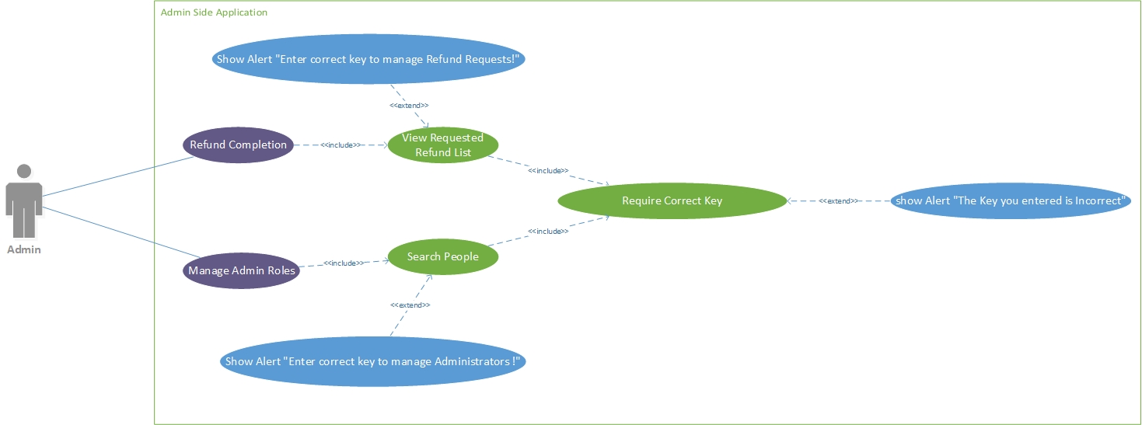

*Admin Side Application Use Case Diagram*

|  |  |  |
| --- | --- | --- |
| Use case Name: | Refund Completion | |
| Actor Name: | Admin | |
| Related Use case: | 1.) View Requested Refund List, 2.) Show Alert "Enter correct key to manage Refund Requests!", 3.) Require Correct Key, 4.) show Alert "The Key you entered is Incorrect" | |
| Goal: | Able to complete refund request | |
| Precondition: | User Must Login into Admin | |
| Summary: |  | |
| Step | **Actor** | **System** |
| 1 | Click on Refund Page | Ask for password. Show Alert "The Key you entered is Incorrect" if key is not correct. |
| 2 | Refund from Myanpay account manually |  |
| 3 | Click on “Complete” button | Show Alert "Enter correct key to manage Refund Requests!" if user didn’t entered the key. |
|  |  | Clear the refund request. |
| Post Condition: | Clear the refund request and Restaurant will get the notification. | |

|  |  |  |
| --- | --- | --- |
| Use case Name: | Manage Admin Roles | |
| Actor Name: | Admin | |
| Related Use case: | 1.) Search People, 2.) Show Alert "Enter correct key to manage Administrators!", 3.) Require Correct Key, 4.) show Alert "The Key you entered is Incorrect" | |
| Goal: | Add or Remove Admin roles | |
| Precondition: | User Must Login into Admin | |
| Summary: |  | |
| Step | **Actor** | **System** |
| 1 | Click on “Manage Admin” Page | Ask for password. Show Alert "The Key you entered is Incorrect" if password is not correct. |
| 2 | Search for users | Show Alert "Enter correct key to manage Administrators!" if user didn’t enter the key.  Search results will show if the key is correct. |
| 3 | Click on “add” or “remove” icon | Change the role of admin |
| Post Condition: | Role of the user will change | |

# 5. QR Scan Use Case Diagram

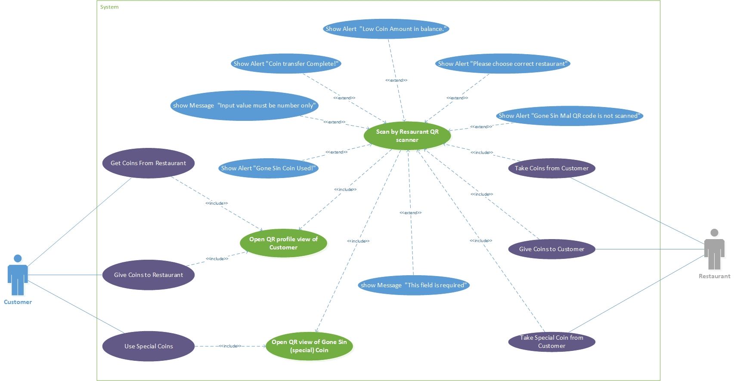

*Admin Side Application Use Case Diagram*

|  |  |  |  |
| --- | --- | --- | --- |
| Use case Name: | Take Coins from Restaurant – Give Coins from customer | | |
| Actor Name: | Customer, Restaurant | | |
| Related Use case: | 1.) Open QR profile view of Customer, 2.) Scan by Restaurant QR scanner, 3.) Show Alert "Gone Sin Mal QR code is not scanned", 4.) Show Alert "Coin transfer Complete!", 5.) Show Alert "Low Coin Amount in balance." 6.) Show Message "This field is required", 7.) show Message "Input value must be number only" | | |
| Goal: | Coin successfully transferred. | | |
| Precondition: | Require Customer login on one phone and Restaurant login on one phone. | | |
| Summary: |  | | |
| Step | **Customer** | **System** | **Restaurant** |
| 1 | Open QR profile |  | Open Scanner and toggle bottom to Give Coins |
| 2 |  |  | Enter Coin Amount |
| 3 |  | Show Message “Input value must be number only" if user enter character values.  Show Message “This field is required" if user did not enter coin amount.  Show Alert "Gone Sin Mal QR code is not scanned" if customer profile QR is not scanned.  Show Alert "Low Coin Amount in balance." If Restaurant has not enough Coins. | Click on “Scan Now” Button by putting customer’s QR profile in camera view. |
| Post Condition: | Coins will be transfer. | | |

|  |  |  |  |
| --- | --- | --- | --- |
| Use case Name: | Give Coins from Restaurant – Take Coins from customer | | |
| Actor Name: | Customer, Restaurant | | |
| Related Use case: | 1.) Open QR profile view of Customer, 2.) Scan by Restaurant QR scanner, 3.) Show Alert "Gone Sin Mal QR code is not scanned", 4.) Show Alert "Coin transfer Complete!", 5.) Show Alert "Low Coin Amount in balance." 6.) Show Message "This field is required", 7.) show Message "Input value must be number only" | | |
| Goal: | Coin successfully transferred. | | |
| Precondition: | Require Customer login on one phone and Restaurant login on one phone. | | |
| Summary: |  | | |
| Step | **Customer** | **System** | **Restaurant** |
| 1 | Open QR profile |  | Open Scanner and toggle bottom to take Coins |
| 2 |  |  | Enter Coin Amount |
| 3 |  | Show Message “Input value must be number only" if user enter character values.  Show Message “This field is required" if user did not enter coin amount.  Show Alert "Gone Sin Mal QR code is not scanned" if customer profile QR is not scanned.  Show Alert "Low Coin Amount in balance." If Customer has not enough Coins.  Show Alert "Coin transfer Complete!" if coin transaction is successful. | Click on “Scan Now” Button by putting customer’s QR profile in camera view. |
| Post Condition: | Coins will be transfer. | | |

|  |  |  |  |
| --- | --- | --- | --- |
| Use case Name: | Get Coins from Restaurant | | |
| Actor Name: | Customer, Restaurant | | |
| Related Use case: | 1.) Open QR view of Gone Sin (special) Coin, 2.) Scan by Restaurant QR scanner, 3.) Show Alert "Gone Sin Mal QR code is not scanned", 4.) Show Alert "Gone Sin Coin Used!", 5.) Show Alert "Please choose correct restaurant" 6.) Show Message “This field is required", 7.) show Message “Input value must be number only". | | |
| Goal: | Gone-sin coins are successfully removed from Customer. | | |
| Precondition: | Require Customer login on one phone and Restaurant login on one phone. | | |
| Summary: |  | | |
| Step | **Customer** | **System** | **Restaurant** |
| 1 | Open Gone Sin QR from Gone-Sin page |  | Open Scanner |
| 2 |  |  | Enter Coin Amount |
| 3 |  | Show Message “Input value must be number only" if user enter character values.  Show Message “This field is required" if user did not enter coin amount.  Show Alert "Gone Sin Mal QR code is not scanned" if customer profile QR is not scanned.  Show Alert "Gone Sin Coin Used!" if gone-sin coins are successfully removed from Customer.  Show Alert "Please choose correct restaurant" if Gone Sin Package and restaurant name does not match. | Click on “Scan Now” Button by putting customer’s Gone Sin QR profile in camera view. |
| Post Condition: | Gone-sin coins are successfully removed from Customer. | | |